  

**DESIGN AND SIMULATION OF MICROSTRIP PATCH ANTENNA FOR BREAST CANCER DETECTION**

A Minor Project Report

**Submitted By**

|  |  |
| --- | --- |
| **NAVEENA K** | **927621BEC136** |
| **PADMAVATHI S** | **927621BEC141** |
| **PAVIPRAVEENA G** | **927621BEC142** |
| **PAVITHRA G** | **927621BEC143** |

### BACHELOR OF ENGINEERING

in

### DEPARTMENTOF ELECTRONICS AND COMMUNICATION ENGINEERING

**M.KUMARASAMY COLLEGE OF ENGINEERING**

(Autonomous)

### KARUR – 639 113

**DECEMBER 2022**

# M.KUMARASAMY COLLEGE OF ENGINEERING, KARUR

### BONAFIDE CERTIFICATE

Certified that this project report “DESIGN AND SIMULATION OF MICROSTRIP PATCH ANTENNA FOR BREAST CANCER DETECTION” is the Bonafide work of “**S.PADMAVATHI** (**927621BEC141**), K. **NAVEEVA** (**927621BEC136**),

**G.PAVIPRAVEENA** (**927621BEC142**), **G. PAVITHRA** (**927621BEC143**)” who carried out project work under my supervision in the academic year 2022-2023.

|  |  |
| --- | --- |
| **SIGNATURE** | **SIGNATURE** |
| Dr.S.PALANIVELRAJAN, M.E., Ph.D., | Dr.D .JAYASEELAN,M.Tech.,Ph.D., |
| **HEAD OF THE DEPARTMENT,** | **SUPERVISOR,** |
| Professor, | Assistant Professor, |
| Department of Electronics and | Department of Electronics and |
| Communication Engineering, | Communication Engineering, |
| M.Kumarasamy College of Engineering, | M.Kumarasamy College of Engineering, |
| Thalavapalayam, Karur-639113. | Thalavapalayam, Karur-639113. |

This Minor project-I report has been submitted for the **18ECP103L – Minor Project-I**

Review held at M. Kumarasamy College of Engineering, Karur on _________

**PROJECT COORDINATOR**

**Vision of the Institution**

To emerge as a leader among the top institutions in the field of technical education

#### Mission of the Institution

**M1:** Produce smart technocrats with empirical knowledge who can surmount the global challenges

**M2:** Create a diverse, fully engaged, learner-centric campus environment to provide quality education to the students

**M3:** Maintain mutually beneficial partnerships with our alumni, industry, and Professional associations Vision of the Department

#### Vision of the Department

To empower the Electronics and Communication Engineering students with emerging technologies, professionalism, innovative research, and social responsibility.

#### Mission of the Department

**M1:** Attain the academic excellence through innovative teaching learning process, research areas & laboratories and Consultancy projects.

**M2:** Inculcate the students in problem solving and lifelong learning ability.

**M3:** Provide entrepreneurial skills and leadership qualities.

**M4:** Render the technical knowledge and skills of faculty members.

#### Program Educational Objectives (PEOs):

**PEO1: Core Competence:** Graduates will have a successful career in academia or industry associated with Electronics and Communication Engineering.

**PEO2: Professionalism:** Graduates will provide feasible solutions for the challenging problems through comprehensive research and innovation in the allied areas of Electronics and Communication Engineering.

**PEO3: Lifelong Learning:** Graduates will contribute to the social needs through lifelong learning, practicing professional ethics and leadership quality.

**Program Outcomes (POs):**

**PO 1: Engineering knowledge:** Apply the knowledge of mathematics, science, engineering fundamentals, and an engineering specialization to the solution of complex engineering problems.

**PO 2: Problem analysis:** Identify, formulate, review research literature, and analyze complex engineering problems reaching substantiated conclusions using first principles of mathematics, natural sciences, and engineering sciences.

**PO 3: Design/development of solutions:** Design solutions for complex engineering problems and design system components or processes that meet the specified needs with appropriate consideration for the public health and safety, and the cultural, societal, and environmental considerations.

**PO 4: Conduct investigations of complex problems:** Use research-based knowledge and research methods including design of experiments, analysis and interpretation of data, and synthesis of the information to provide valid conclusions.

**PO 5: Modern tool usage:** Create, select, and apply appropriate techniques, resources, and modern engineering and IT tools including prediction and modeling to complex engineering activities with an understanding of the limitations.

**PO 6: The engineer and society:** Apply reasoning informed by the contextual knowledge to assess societal, health, safety, legal and cultural issues, and the consequent responsibilities relevant to the professional engineering practice.

**PO 7: Environment and sustainability:** Understand the impact of the professional engineering solutions in societal and environmental contexts, and demonstrate the knowledge of, and need for sustainable development.

**PO 8: Ethics:** Apply ethical principles and commit to professional ethics and responsibilities and norms of the engineering practice.

**PO 9: Individual and teamwork:** Function effectively as an individual, and as a member or leader in diverse teams, and in multidisciplinary settings.

**PO 10: Communication:** Communicate effectively on complex engineering activities with the engineering community and with society at large, such as, being able to comprehend and write effective reports and design documentation, make effective presentations, and give and receive clear instructions.

**PO 11: Project management and finance:** Demonstrate knowledge and understanding of the engineering and management principles and apply these to one’s own work, as a member and leader in a team, to manage projects and in multidisciplinary environments.

**PO 12: Life-long learning:** Recognize the need for and have the preparation and ability to engage in independent and life-long learning in the broadest context of technological change.

#### Program Specific Outcomes (PSOs):

**PSO1:** Applying knowledge in various areas, like Electronics, Communications, Signal processing, VLSI, Embedded systems etc., in the design and implementation of Engineering application.

**PSO2:** Able to solve complex problems in Electronics and Communication Engineering with analytical and managerial skills either independently or in team using latest hardware and software tools to fulfil the industrial expectations **Program Specific Outcomes**

**PSO1:** Applying knowledge in various areas, like Electronics, Communications, Signal processing, VLSI, Embedded systems etc., in the design and implementation of Engineering application.

**PSO2:** Able to solve complex problems in Electronics and Communication Engineering with analytical and managerial skills either independently or in team using latest hardware and software tools to fulfil the industrial expectations.

|  |  |
| --- | --- |
| **Abstract** | **Matching with POs, PSOs** |
| keywords | PO1, PO3, PO9, PSO1 |

### ABSTRACT

Microstrip patch antenna is mostly used in modern communication devices over conventional antennas.Breast cancer affects many women and has fatal conclusions if it does not cure correctly.As the stage increases, the chances of treatment and probability of survival of patient decreases.Hence, early diagnosis is the most important parameter to detect and interfere with cancer tissue. Some of methods for breast cancer detection are X- ray, mammography, MRI and Ultrasound .These methods have several limitations, so as a alternating method basic microstrip patch antenna for early detection of breast cancer is designed.This paper presents recent trends in microstrip patch antenna design for early breast cancer detection and comparison among them in terms of substrate,feeding techniques and some other parameters.

Breast cancer affects many women and has fatal conclusions if it does not cure correctly. Early diagnosis is the most important parameter to detect and interfere with cancer tissue.Some of methods for breast cancer detection are X-ray mammography, MRI and ultrasound.These methods have several limitations,so as a alternating method we design basic Micro strip antenna for early detection of breast cancer.

**Keywords**: HFSS, Microstrip patch antenna, Permittivity, Tumor size.

### Table of Contents

|  |  |  |
| --- | --- | --- |
| **S. No.** | **Particulars** | **Page No.** |
|  | Vision and Mission of the institute and department | 3 |
|  | POs, PSOs of the department | 4 |
|  | Abstract | 7 |
|  | List of figures | 9 |
|  | List of abbreviations | 10 |
| 1 | Introduction | 11 |
| 2 | Literature review | 11 |
| 3 | Methodology | 12 |
| 4 | Tools used | 14 |
| 5 | Experimental Techniques | 14 |
| 6 | Materials are Used | 15 |
| 7 | Simulation And Results | 15 |
| 8 | Conclusion | 17 |
|  | Reference | 18 |

**List of Figures**

|  |  |  |
| --- | --- | --- |
| **Figure No** | **Figure Name** | **Page No** |
| 3.1 | Antenna Design | 13 |
| 7.1 | S Parameter Without Tumor | 15 |
| 7.2 | VSWR Parameter Without Tumor | 16 |
| 7.3 | VSWR Parameter With Tumor | 17 |
| 7.4 | Gain of Rogers5880 material | 17 |
|  |  |  |

**LIST OF ABBREVIATIONS**

|  |  |  |
| --- | --- | --- |
| HFSS | - | High Frequency Structure Simulator |
| DC | - | Direct Current |
| VSWR | - | Voltage Standing Wave Ratio |
| S Parameter | - | Scattering Parameter |
| PN | - | Positive Negative |

**1. INTRODUCTION**

Antennas are key components of any wireless system. An antenna is a device that transmits and/or receives electromagnetic waves. Most antennas are resonant devices, which operate efficiently over a relatively narrow frequency band. An antenna must be tuned to the same frequency band that the radio system to which it is connected operates in, otherwise reception and/or transmission [1] .

Over the past one decade, there is a rapid growth in development of wireless communication applications and the performance of all such wireless systems depends on the design of antennas. Antennas play a major role in such medical monitoring systems since they provide communication between sensor and external equipment. Due to many advantages microstrip antennas are preferred for majority of biomedical applications and it has become a rapidly growing area of research. Their potential applications are limitless, because of their light weight, compact size, and ease of manufacturing. However, the design of such antennas is quite challenging in terms of antenna size, impedance matching, low power requirements, and biocompatibility with the body’s physiology [1].

**2. LITERATURE SURVEY**

Microwave imaging is developing as a promising technology with various biomedical applications. In the case of breast imaging, this technique entails transmitting short pulses of low-power microwaves into the breast tissue. Antennas positioned around the breast are used to collect the back-scattered energy, and the received signals are used to produce a three-dimensional image of the scanned breast. A comparison between an X-ray image and a microwave image for a cancer patient [2].

**3.** **METHODOLOGY**

The methodology for design and development of microstrip patch antenna depends on various techniques used to simulate different parameters of the antenna. The proposed antenna was designed using Rogers5880 substrate. The major performance parameters such as antenna gain, bandwidth and return loss were observed [2].

**EXISTING METHOD**

The cancer imaging technique is decisive or crucial for early breast cancer detection. There are several cancer imaging techniques that are currently in use such as Breast SelfExamination (BSE) and Clinical Breast Examination (CBE), Breast Ultrasound, Computerized Tomography (CT), Magnetic Resonance Imaging (MRI), Positron Emission Tomography (PET), Mammography and other breast screening methods. However, these techniques are currently in use, but still have some weaknesses. PET is not effective for primary tumor detection. Mammography is considered as gold standard for breast screening, but it is ineffective in younger women and for those with dense breasts. X-Rays cause breakage of human body cells and tissues, magnetic rays involved in MRI has poor imaging capabilities for superficial soft tissues. Mammography involves ionizing radiations and has slow imaging time and is non portable [1].

**NEW METHOD**

In breast cancer detection antenna, transmitting antenna transmits the electromagnetic waves to the tissue and receive the scattering waves from the tissue by the receiving antenna. Here, a 3D breast structure with different permittivity and conductivity is modelled in HFSS.The proposed antenna is placed over the breast structure. Here, rectangular micro strip patch antenna is used as an antenna structure. By investigating electromagnetic field over the breast tissue, we can detect the tumor present in the tissue as permittivity of tissues and tumor varies [3].

**3.1. ANTENNA DESIGN**

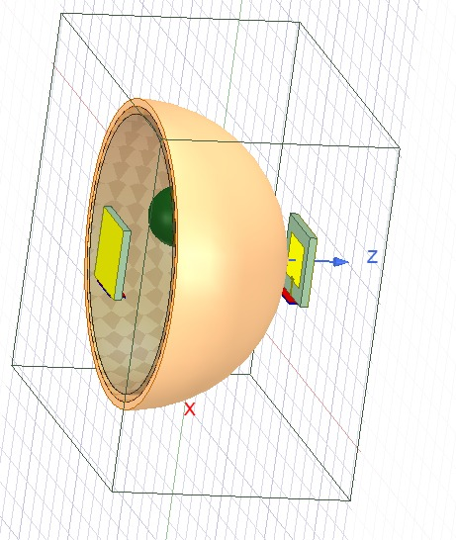

**Figure 3.1 Antenna Design**

**4. TOOLS USED**

**SOFTWARE REQUIREMENT**

* + - HFSS SOFTWARE (HIGH FREQUENCY SIMULATION SOFTWARE )

Ansys HFSS is a 3D electromagnetic (EM) simulation software for designing and simulating high-frequency electronic products such as antennas, antenna arrays, RF or microwave components, high-speed interconnects, filters, connectors, IC packages and printed circuit boards [1].

**5. EXPERIMENTAL TECHNIQUES**

The structural parameters of rectangular microstrip antenna obtained on the basis of theoretical rectangular waveguide model which is one of the finest models for the explanation of the working for this type of antenna structures. With the theoretical calculation antenna has been simulated and optimized by EM Talk Microstrip Patch Antenna and Microstrip Line calculator. The design of antennas was explained in following steps. First step was to choose the operating frequency (fr) at which the microstrip patch antenna to be designed. In present investigation, the proposed microstrip patch antenna was designed at operating frequency 2.4 GHz. The second step was selection of substrate material with required values of input design parameters such as permittivity, dielectric loss tangent, to miniaturize size of antenna with increased performance [6]**.**

**6. MATERIALS ARE USED**

Antennas can be designed with different substrates to achieve the desired performance. The substrates are chosen taking into consideration the ease of fabrication and its biocompatibility when compared to other semiconductors. The selection of height and dielectric constant of the substrate helps in achieving high directivity and better radiation efficiency. For performance, predictions and simplified analysis, a rectangular shaped microstrip patch antenna operating at 2.4GHz is proposed [4].

**7. SIMULATION & RESULTS**

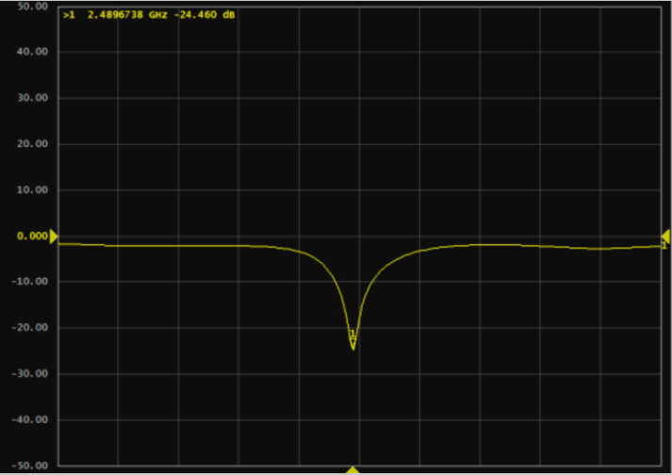

**Fig.no:7.1. S PARAMETER WITHOUT TUMOR**

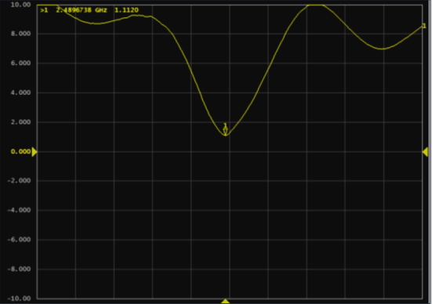

**Fig.no:7.2 VSWR PARAMETER WITHOUT TUMOR**

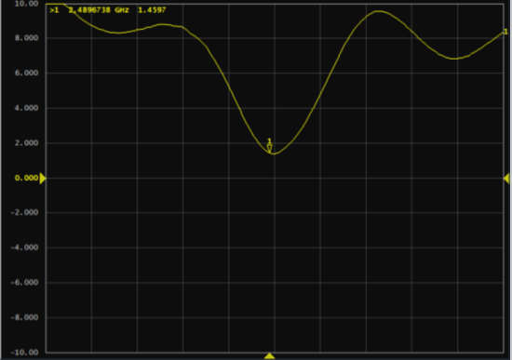

**Fig.no:7.3. VSWR PARAMETER WITH TUMOR**

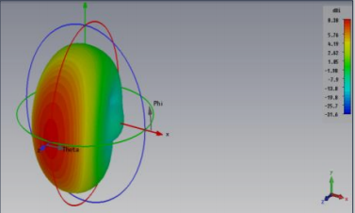

**Fig.no:7.4 GAIN of Roggers5880 Material**

**8. CONCLUSIONS**

Microstrip antennas are used in satellites, missiles, aircraft, space crafts, mobile phones, wireless communication systems, radars, and remote sensing. Some of the advantages of using microstrip antennas in these systems include: Easy to fabricate, modify, and customize. Simple and inexpensive construction.

In recent years, the microstrip patch antenna has widely been used for various specific applications in satellite communications, aerospace, radars, biomedical applications, mobile communication for GSM, and remote sensing applications because of its special features like ease ofanalysis and fabrication, low cost, light weight, easy to feed, capability of dual, triple and several frequency operationsand attractive radiation [8].

Although the patch antenna has several advantages but it has some limitations like narrow bandwidth. The need for wideband antennas operating at higher frequencies is significantly increasing as the various wireless applications require more and more bandwidth. To meet the growing demands of the communication systems, researchers have continuously developed new and effective methods to improve the different features of microstrip patch antennas like polarization, gain, return loss, directivity etc**.** Several research papers based on recent research on design of microstrip patch antenna for breast cancer detection have been reviewed. Microwave imaging is found as a good alternative over other breast screening techniques. Human body exposure to microwaves is harmless. Microwave imaging is a safer and cheaper technique to detect breast tumor as compared to other existing breast screening techniques. Then microstrip patch antennas, wearable and non-wearable antennas for breast cancer detection as well as for other on body applications have been surveyed. According to the reviewed papers, tumor size up to 3mm has been detected till now, but by making compromises with some other parameters such as antenna size, resonant frequency, distance between antenna and human breast. Most of the antennas are found working at single band. Dual band antennas can enhance the performance of microwave imaging, provided the working of antenna within Industrial, Scientific and Medical (ISM) band. Some researchers detect the tumor by making no distance between antenna and human breast [7].

**References**

1. Medical News Today, “Breast Cancer: Symptoms, Risk Factors, and Treatment”, Available at: https://www.medicalnewstoday.com/articles/37136#causes.
2. S. Malvia, S.A. Bagadi, U.S. Dubey and S. Saxena, “Epidemiology of Breast Cancer in Indian Women”, AsiaPacific Journal of Clinical Oncology, Vol. 13, No. 4, pp. 289-295, 2017.
3. K. Vidyasree, T.S. Nagaveni, M. Manisha and B.M. Nandini and H Vinod Kumar, “Breast Cancer Detection using Microstrip Patch Antenna”, International Journal of Advance Research, Ideas and Innovations in Technology, Vol. 4, No. 3, pp. 1378-1379, 2018.
4. Antenna Theory, Available at: http://www.antennatheory.com.
5. Shivam Mokha, Shubham Jangir, Shreyas Pimple and Sumeet Bandhaokar, “Design of Flexible Microstrip Patch Antenna of 2.4GHz Operation Frequency using HFSS”, International Research Journal of Engineering and Technology, Vol. 3, No. 5, pp. 638-644, 2016.
6. C.A. Balanis, “Antenna Theory, Analysis and Design”, 3rd Edition, John Wiley and Sons, 2005.
7. K. Ouerghi, N. Fadlallah, A. Smida, R. Ghayoula, J. Fattahi and N. Boulejfen, “Circular Antenna Array Design for Breast Cancer Detection”, Proceedings of International Conference on Sensor Networks Smart and Emerging Technologies, pp. 1-8, 2017.
8. M.H. Bah, J.S. Hong, D.A. Jamro, “Study of Breast Tissues Dielectric Properties in UWB Range for Microwave Breast Cancer Imaging”, Proceedings of International Conference on Computer Information Systems and Industrial Applications, pp. 1122-1128, 2015. [9] K. Ouerghi, A. Smida, R. Ghayoula and N. Boulejfen, “Design and Analysis of a Microstrip Antenna Array for Biomedical Applications”, Proceedings of 3rd International Conference on Advanced Technologies for Signal and Image

